We are working with L&Q to build the first LGBT co-housing scheme in the UK
COMMENT30/07/20BY AMANDA GIRLING-BUDD
L&Q is using its financial muscle and development expertise to help us bring forward a pioneering housing scheme for the LGBT community, writes Amanda Girling-Budd

Amanda Girling-Budd is a member of London Older Lesbian Cohousing
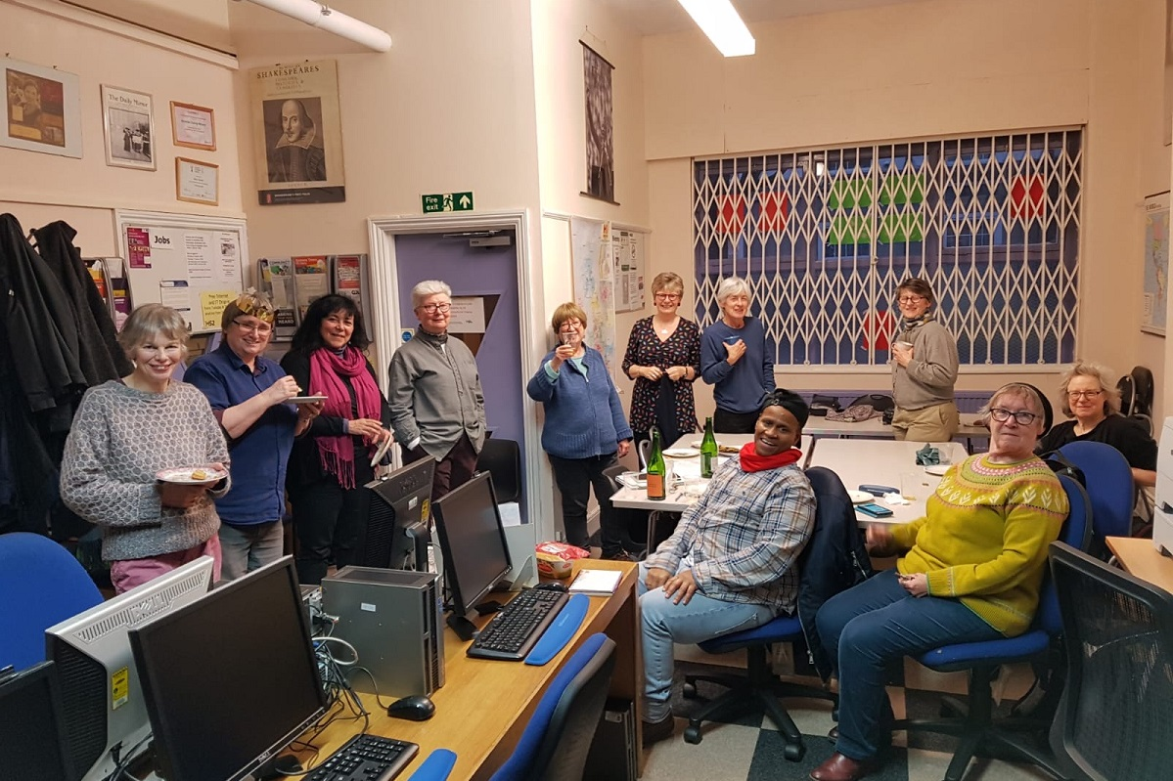
Members of LOLC at their Christmas party (picture: LOLC)

L&Q is using its financial muscle and development expertise to help us bring forward a pioneering housing scheme for the #LGBT community, writes Amanda Budd #UKHousing

We are working with L&Q to build the first #LGBT co-housing scheme in the UK, writes Amanda Girling Budd #UKHousing

In a recent Inside Housing comment piece, David Montague, chief executive of L&Q, pointed out some of the lessons his organisation has learned from the COVID-19 crisis.
He highlighted the need to support and protect vulnerable people, from older people to LGBT and BAME groups.
He also emphasised the importance of forming and maintaining partnerships with small housing associations, community organisations and the government, to provide affordable housing for those who need it.
The experience of London Older Lesbian Cohousing (LOLC), of which I have been a member since 2017, bears out L&Q’s renewed commitment to community projects, particularly those that serve vulnerable groups. We have been working with L&Q since before coronavirus hit to develop a small co-housing community – the first LGBT co-housing scheme in the UK.

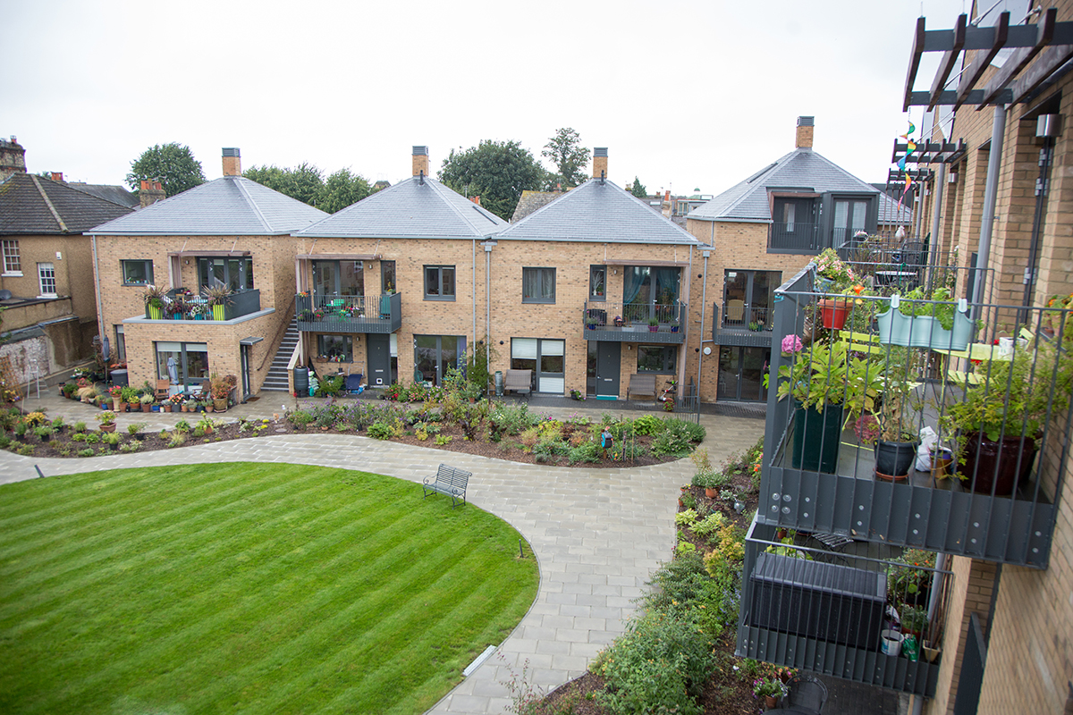Co-housing for older women
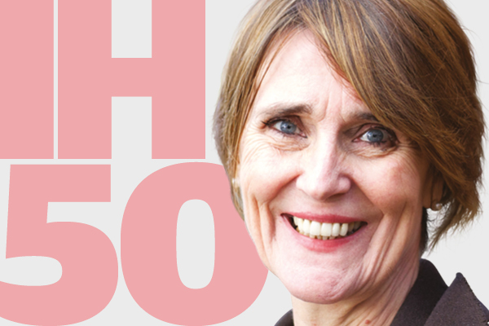Embedding LGBT rights as lived experience is our responsibility as housing providers
Housing scheme for older LGBT people planned for Manchester
Pride in our planned LGBT extra care scheme

Our relationship with L&Q grew out of the housing association’s Build London Partnership (BLP) with the mayor of London. Many small housing associations do not have the clout to develop affordable housing schemes on their own and this unique collaboration has seen L&Q form a specialist ‘strategic partnerships’ team to support them.
The team uses L&Q’s extensive experience in development to build capacity in the sector, helping its partners procure land and build new homes, unlocking small sites across London in the process.
We are not a housing association, so we fell outside the remit of the mayor’s initiative, but L&Q was keen to work with us anyway, recognising the specific needs of an ageing, ‘out’ LGBT community.
Co-housing is a different way to address the needs of older people. What we are planning is not an alternative to a care home, but perhaps an alternative to sheltered housing, where we live in the same building complex, each with our own apartment and our own front door, but with shared facilities and communal space including a garden, dining room and kitchen. The design and fabric of the development will foster social life and mutual support.
During this crisis, I have been delivering prescriptions every week to housebound and older residents in my borough. Most of these residents live in purpose-built sheltered housing or repurposed apartment blocks. The buildings are quite well looked after and glimpses of flats from the appropriate social distance suggest they are nice, too, if a bit cramped.
What is missing is a sense of community. Communal space is mostly limited to corridors and staircases. The most socially active place in most of these buildings is the lift. There is usually no common meeting place and gardens are not designed so that you would want to spend time in them. This means people mostly don’t know their neighbours, and can’t easily socialise or support each other.
In working with our project, L&Q has demonstrated its commitment to supporting those in the community who need it. LOLC’s members are all from vulnerable groups. Despite our liveliness and occasional feistiness, we are all over-55 and most of us are well over that. We are from all backgrounds. Some of us are from ethnic minorities and some are migrants. We have between us many health issues of varying seriousness. We have also suffered discrimination in the past because of our sexuality and we need the assurance that we can continue to be ‘out’ in our final years. Our strapline is ‘supporting each other to have the best rest of our lives’ and that is what we aim to do.
We don’t anticipate needing the kind of support that L&Q is promising its older residents. We won’t need checking up on. We will provide our own support by looking out for each other, which will reduce the burden on landlords, the local borough and health services.
What we do need – now – is support to get us up and running, acquire a site, and plan and build.
“We want to live somewhere beautiful with like-minded people. We don’t think that is too much to ask”
Thankfully, L&Q, true to David’s word, is providing just that. With the support of the BLP, we are exploring the possibilities of developing on a small site in north London and have commissioned feasibility studies for the site from architects. We are currently poring over plans, figuring out where the sun will be, how far away the bus stop is and how best to situate our communal spaces so that they enable our community to flourish.
We expect both partners will learn lessons along the way – L&Q will be working with a co-housing scheme for the first time, and we are working with a large housing association and developer. The important thing is that we work together closely to make decisions in the spirit of partnership. This project is special to us, and we have put time, effort and financial resources into it. We want the ability to ensure that the development will fully meet our needs.
L&Q is not our only partner. We have already had support from the Greater London Authority through the Community-Led Housing Hub, which has given us advice and promised funding. We could not have got to this – still early – stage without its help and we will still need it going forward.
We have benefitted from the pioneering work of Older Women’s Cohousing, who completed their scheme in Barnet in 2016. They have inspired us and been generous in sharing their experiences. We hope to partner with a smaller housing association, which will fund and manage the homes for affordable rent and those purchased through the Older People’s Shared Ownership scheme.
We want to live somewhere beautiful with like-minded people. We don’t think that is too much to ask. We hope that with help from our partners, we can be a model for dignified living for LGBT elders – and perhaps for the wider ageing population.
Amanda Budd, member, London Older Lesbian Cohousing (LOLC)

